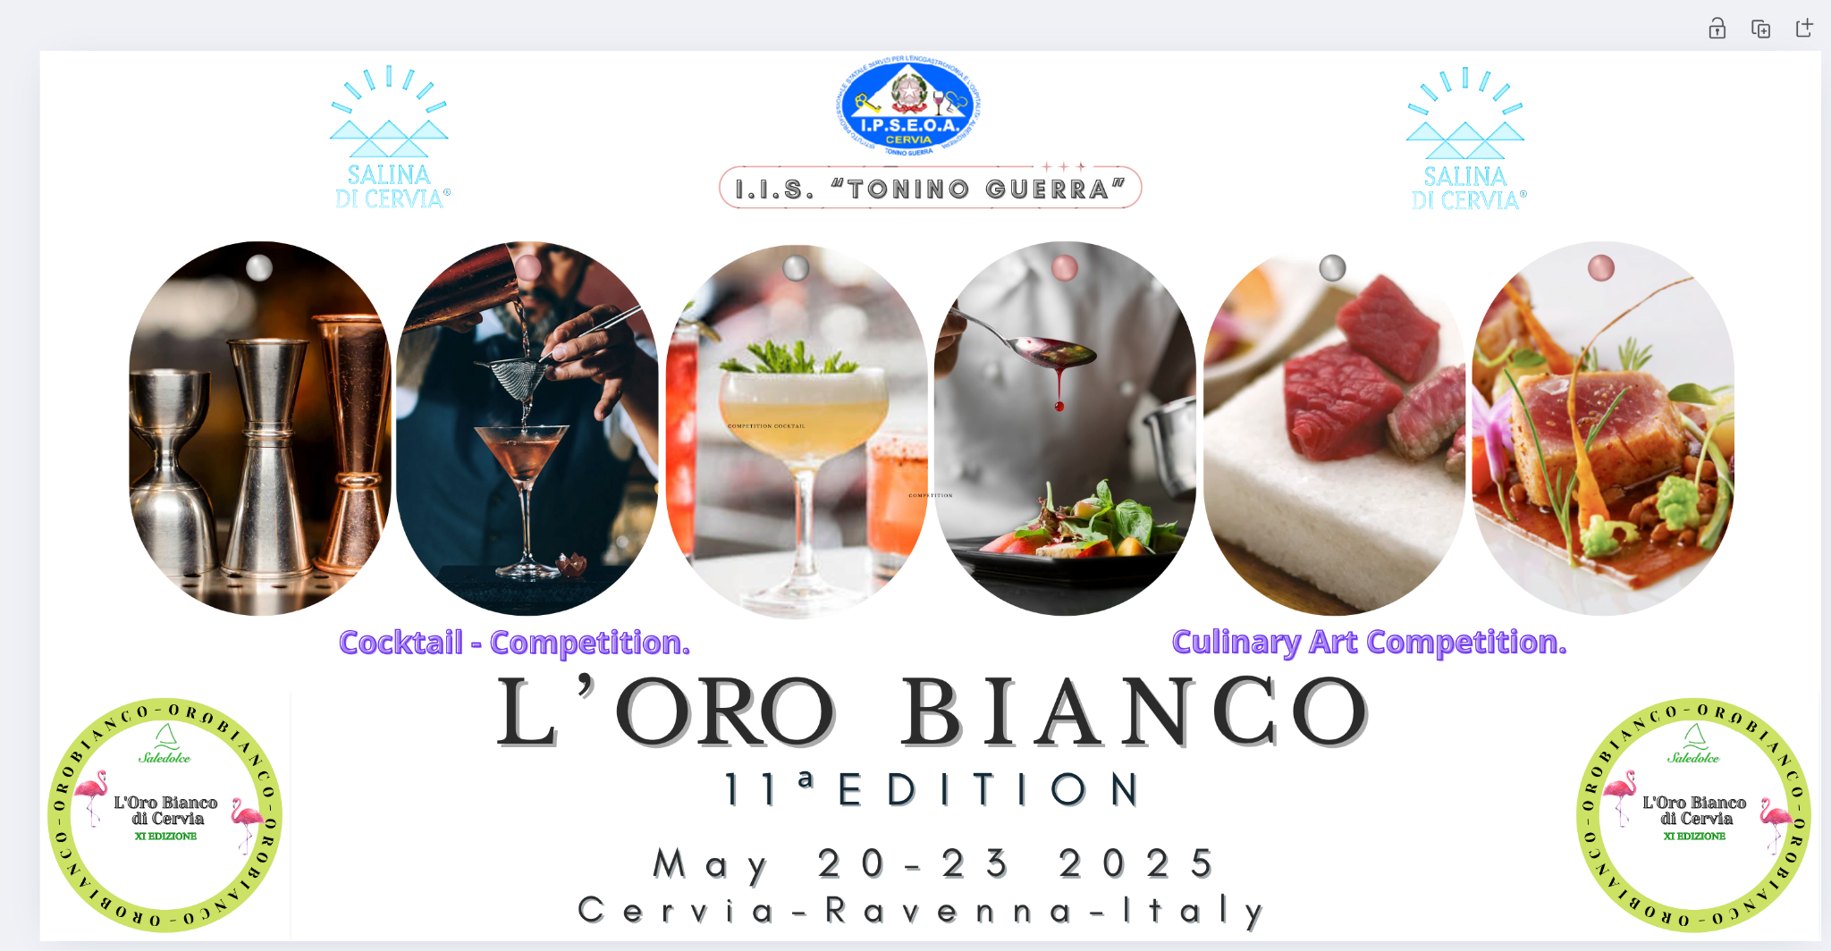

**11th**

**European Culinary art & Cocktail Competition**

“L’oro Bianco di Cervia”

“White Gold of Cervia”

**May 20 - 23 2025**

“**TONINO GUERRA**” Vocational Catering & Hotel Management School of Cervia, in collaboration with “**Il Parco della Saline di Cervia srl**”, is organizing the 11th “L’Oro Bianco di Cervia” competition.

***The Competition aims to promote the use of local resources, the creativity and dynamism of young people, triggering professional synergy among students from different institutes.***

***The workshops will become not only a tool for unity but also for experimentation and innovative food and wine routes.***

The Competition will be held at the I.I.S. in Cervia. from May 20 to 23, 2025, (the days of 20 and 23 2025 are reserved for the arrival and departure of participants, while on the days of 21 and 22 the competitions and the gala dinner with awards will be held).

The Competition is restricted to students of the National and European Hotel Institutes who are attending the **3rd, 4th and 5th classes** in the 2024/2025 school year of Cookery / Pastry and Cocktail courses.

The School “Tonino Guerra”, as the host school, will not participate in the Competition.

Invited, free of charge, are N. 2 students (1 from the cookery and 1 from the service course) and N.1 teacher;

School delegations arriving from places more than 70 kilometers away will be able to take advantage of free accommodation from the evening of Tuesday, May 20th to the morning of Friday, May 23rd , 2025 upon request through the relevant “ Registration Form.”

While schools coming from less than 70 km will be able to arrive on the morning of May 21st , or use the overnight accommodation at their own charge,

**Hotel accommodation:** teachers in single rooms, students in multiple rooms. extra teachers to be paid by the participating school.

Schools must send their applications to TONINO GUERRA in Cervia by **Saturday, March 15th, 2025 by filling out the format available at the following link:**

<https://forms.gle/xB43K6HKAFBjjdVq7>

Please note that in order to ensure a high standard of organization, the number of registered schools will be restricted, and a selection will be prepared according to the following criteria:

* ***date of receipt of Application Form***
* ***date of receipt of Complete Documentation***

The registration confirmation will be communicated to the delegations by Saturday 22nd March 2025.

An online meeting will be organized for selected schools by I.I.S. Tonino Guerra of Cervia to clarify all the aspects of organization and logistics in each competition area.

**Schools MUST REGISTER IN BOTH SECTORS of the Competition.**

|  |
| --- |
| **CULINARY ART** |

Each school must present a recipe for a creative and sustainable dish to be chosen from

* Appetizer;
* First course;
* Main dish;
* Dessert.

The preparation of the dish must include Sweet Salt Cervia as a compulsory ingredient.

**RECIPE CHARACTERISTICS**

For the preparation of the dishes:

* No additives such as, Glutamates and Artificial Dyes shall be used;
* Natural products such as starch, agar-agar, spice mixes, pesto, jams, flavored salts, extra
* virgin olive oil, dried fruits, etc. may be used instead.
* Each institute must submit a recipe with seasonal products and at least one ingredient from its local area.

**During the final task,** the cooking competitors will be able to enter the laboratories at 15-minute intervals from each other, following the order set on the basis of the draw that took place previously. It should be noted that the exit of the dishes will also follow the same order. Delay with respect to the predetermined time will constitute a penalty that the jury will take into account.

During the final task, the cooking competitors will be able to enter the laboratories at 15 - minute intervals from each other, following the order set on the basis of the draw that took place previously.

It should be noted that the exit of the dishes will also follow the same order. Delay with respect to the predetermined time will constitute a penalty that the jury will take into account.

**By April 12, 2025, therefore, it will be necessary to upload through the following link:**

recipe sheet (Pdf and Word file) for 5 people with description of ingredients,

procedure, equipment needed

● digital photo of the dish JPG;

● completed glycemic load sheet;

The docx files of the sheets are attached to the application.

|  |
| --- |
| **RULES** |

**The cooking students** will have to make the dish by the maximum time limit of 90 minutes. Times are scheduled in the following ways:

* 5 minutes for preparation of the mise en place;
* 70 minutes for preparation of the dish;
* 15 minutes for presentation of the dish to the judges and clean-up of the workstation.

The culinary students will have to make the dish for 5 people (5 tastings and 1 dish to be shown), observing the hygienic and sanitary regulations under current laws and tidying up their station.

The students will present the dish to the judges by reporting on:

* the ingredients used
* timing and ways of cooking
* nutritional Values
* Sustainability
* Customizing the dish with Cervia salt.

**Ingredients and food products necessary for the execution of the dish, as well as special equipment, must be brought by the participating Institutes.**

All those who are unable to bring their own products may apply in advance to the School, specifying type, size, etc., and anything else useful for purchase, knowing, however, **that products from the Romagna REGION/coast may differ greatly from those from the region of origin.**

**Please inform them of this requirement at the same time as sending the recipes.**

Serving dishes of any shape and size can be brought by participating schools (in the event that they do not have their own, serving dishes will be provided by Cervia School).

**Be very careful:** no ingredients that are not specifically stated in the recipe are allowed, nor are any pre-cooked products. Only any decorations of edible material made and assembled during the course of the test will be accepted. Long-resting doughs will have to be proven. It is recommended to make express cooking preparations.

No unauthorized persons will be allowed in the kitchen during the course of the competition; assistance to the students will be provided exclusively by the Cervia School staff.

**The jury will consist of 5 people who are professionals in the food and wine industry: and will evaluate according to the parameters and scores specified below:**

* Empowerment of Cervia salt 1 to 20
* Presentation 1 to 10
* Tasting 1 to 30
* Professional preparation 1 to 10
* Sustainability 1 to 10
* Order, cleanliness, precision of execution and manual skills

(as indicated by the school's Kitchen judges). 1 to 20

**Penalties**

Over time preparation (max 16 min) -1 point for every 2 minutes (from the total realized) over 16 minutes the dish will pass last.

**The jury is the only competent authority to judge the applications and practical tests. Its decision is final and no appeals are allowed.**

|  |
| --- |
| **COCKTAIL COMPETITION** |

**The cocktail competition** consists of the presentation and execution **of an unreleased Alcoholic Cocktail and Mocktail** (number 2 servings for each) following the rules below.

**By April 12, 2025, therefore, it will be necessary to upload through the following link:**

<https://forms.gle/n52gNxDMQfzCSAye6>

● the recipe worksheet (Pdf or Word file) for 5 people with a description of ingredients, method, and equipment needed

● Digital photo of the dish JPG;

● completed glycemic load sheet;

The docx files of the sheets are attached to the announcement.

|  |
| --- |
| **RULES** |

Each student will prepare an “ **Unedited Alcoholic Cocktail” ( No.2 portions)** with a creative and personal recipe, which is contextualized in the world of modern mixology. **The recipe must HIGHLY take into consideration a product from the local area of the school participating.**

This recipe can be made up of a maximum of 7 ingredients; **ANY** mixing method and home-made products will be allowed if provided with the technical data sheet (ingredients and process). The recipe may measure from a minimum of 9 cl to a maximum of 20 cl.

For the garnishing of the **Alcoholic Cocktail, there are no restrictions**: only fantasy and originality will be evaluated.

**The recipe will be allowed to be served in any container which is appropriate for beverages (glasses, jars, cans, bottles, tin cans, etc.), but emptied fruit will not be allowed to be used as a beverage recipient.**

The time limit for the cocktail performance only will be 7 minutes.

During the challenge, the judges will discuss with the student after the challenge about the products used in the cocktail (legends, anecdotes, history, merceology, etc.).

As an additional evaluation.

After that, each student will prepare a “Mocktail” (n. 2 servings) with a creative and personal recipe, contextualized in the world of modern mixology. The recipe may be made up of a maximum of 7 ingredients; ANY kind of mixing technique may be used.

**Pre-made decorations will not be allowed, and they must be edible.**

The recipe may measure from a minimum of 9 cl to a maximum of 20 cl. The Maximum time for the execution of the mocktail alone will be 7 minutes.

After the test, the judges will discuss with the student about the products used in the Mocktail, (legends, anecdotes, history, etc.).

For both preparations the ingredients, glasses and equipment are the responsibility of the school participating. For equipment and glasses in case of real need (example those who join us by plane) IIS Tonino Guerra will provide its own upon contact and agreement by email oro.bianco@iiscervia.it or by calling the sector contact teacher Cutolo Francesco. (please see the bottom of the application)

**Carrying out of the cocktails competition**

On Wednesday, the participating institutes from the beginning of the competition until its end will have their cocktails and moktails prepared for the occasion tasted upon request by the guests of IIS Tonino Guerra and the other competing institutes (tastings of about 2cl). the jury formed by experts in the field will visit in numerical order (draw in the morning after the briefing) all the competing institutes and only at this stage the competing student will have to prepare independently the two competing recipes. for the rest of the day instead the presence and help of the accompanying teacher is allowed (even more than one).

**each participating school will have available:**

● a buffet table (2.20\2.50 mt) already dressed with appropriate linens

● an ice basket (22x22x16 cm)

● ice cubes hoshizaki 22gr

● ice crush hoshizaki

● a student from our institute to work alongside for the duration of the contest

● an “office” point for appropriate preparations set up with a kitchen cutting board and containers for sorting waste

● a power point upon request

● compostable shot glasses for tastings

● all the availability of ISS Tonino Guerra staff and students involved in the event.

During the course of the competition, no people from outside the jury will be allowed in the office or near the work bench; support for the students will be provided exclusively by IIS Tonino Guerra of Cervia staff.

**The jury is the only competent authority to judge the applications and practical tests.**

**Its decision is final and no appeals are allowed.**

**COCKTAIL EVALUATION**

Competitors will be evaluated with the following marks:

* **Dialectical comparison with judges Mocktails test from 0.5 to 10 points**
* **Dialectical comparison with judges Cocktails test from 0.5 to 10 points**

- after the presentation of the recipe, the judges will ask the contestant a few questions about the commodity and identity of the products, mixing technique, equipment, glasses and anything else that is used in the making of the recipe.

**Mocktails test evaluation**

evaluation will be divided as follows:

**●** execution of the recipe (adherence to dosage, filling of glasses, use of equipment and interpretation of the chosen mixing technique) **from 0.5 to 7 points**

**●** appearance and taste of the cocktail f**rom 0.5 to 3 points**

**Cocktails test evaluation**

● execution of the recipe (adherence to doses, filling of glasses, use of equipment and interpretation of the chosen mixing technique) **from 0.5 to 7 points**

● appearance and taste of the cocktail **from 0.5 to 3 points**

**Maximum 40 points**

**PENALTY.**

During the in-office preparation phases an auxiliary judge will assign any penalty points to be **SUBTRACTED** from the final result with the following table:

● Time exceeded max preparation period 2.5 points per 30 seconds

● Do not tidy up the work station 0.5 to 5 points

● Incorrect waste disposal 0.5 to 5 points

|  |
| --- |
| **INSTITUTE FOOD AND WINE TOURISM PRIZE** |

**SETTING UP A STAND AT EVENT OF GALA DINNER.**

Each institute must set up a space where they can show and have tastings of typical products from their home area. The aim of the set-up is also to better promote the products of the area. The equipment needed to set up the stand is the responsibility of each individual school, the organization will provide:

1. an outdoor gazebo space if the weather allows or a buffet inside our school.

2. glasses for tasting (type to be arranged with the cocktails competition contact person see bottom of announcement).

3. only to those who will request a 220v electricity point.

4. saucers, small bowls, compostable forks, etc. (always to be agreed upon)

Two of our school (one from the restaurant and one of our cookery students for the tasting service.

**The set-up will take place at 5:00 p.m. on Thursday, May 22nd the technical jury will review the stands from 6:00 p.m. to 7:30 p.m. after which the stands will be opened to the “popular” jury composed of the participating schools and the guests of the TONINO GUERRA in the same time as the gala dinner aperitif.**

**For this moment of competition and conviviality, the participating students will be able to choose to wear gala dress, as they will only have to show their products. the tasting and HACCP regulations will be guaranteed by our students.**

**STAND SET UP SCORE**

A prize is provided for the Institute that best represents its territory of origin.

The award will be given to the Institute that achieved the highest number of preferences.

**RIGHTS**

Participants in the event assign to **IIS “Tonino Guerra” of Cervia all rights** concerning the recipes, reports, menus, materials and photographs, including for possible publications and related television rights.

|  |
| --- |
| **AWARD WINNING** |

The award ceremony will take place at the **Gala Evening** to be held on **Thursday, May 22nd, 2025.**

**Students ranked 1st 2nd and 3rd in each sector will receive prizes provided by the Institute and any prizes provided by sponsors.**

For information and details:

● Kitchen contact teacher. Coppola Nazareno Mobile. 0039 366 3737132 coppola.nazareno@iiscervia.it

● Cocktail contact person Prof. Cutolo Francesco Mobile. 0039 338 212 3665 cutolo.francesco@iiscervia.it

● Reference hotel accommodation facility for EXTRA stays and overnight stays:

[www.hotelbassetti.it](http://www.hotelbassetti.it) Rossi Francesco tel. 0039 0544 987267

[info@hotelbassetti.it](mailto:info@hotelbassetti.it)