

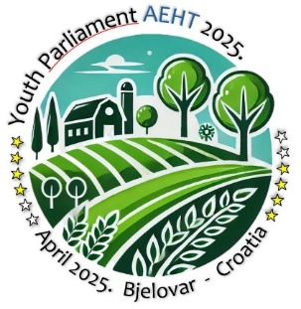

Dear AEHT member schools,

Tourism and hospitality school Bjelovar is inviting the European youth from the AEHT member schools to participate in the

2025 EDITION OF THE YOUTH PARLIAMENT
which will be held in
BJELOVAR, CROATIA

The aim is for young people to learn about diplomacy and international relations, to develop practical international communication skills targeting the topics of sustainability, green skills, and technology, and to promote greater global awareness of contemporary issues in travel and tourism.
This 3-day intensive programme will see a role-play of the simulated European Parliament (MEPs) and numerous debates.
Arrival: Monday, 7 April 2025
Departure: Friday, 11 April 2025

STUDENT PARTICIPATION CRITERIA:
We wish to enable the arrival of as many countries as possible, so the limit is two students per country (one per school), with a maximum of 30 students.
Students shall be 18 years old at the time of travel.
Active participation in debates is required, so the level of English must be at least B2. The participating students will be required to research the topic of the discussion and develop solutions to significant issues identified.
Selected participants send a short report/swot analysis of rural tourism in their area before their arrival - the goal is to prepare for the topic and review the specifics of rural tourism throughout Europe.

GENERAL TOPIC
Rural tourism
TOPICS FOR DEBATING:
- Sustainable development of rural tourism -How can a balance between tourism development and conservation of natural resources be achieved?

- Technology in rural tourism - Is digitisation key to promoting and improving rural tourism?

- Rural tourism as a response to mass tourism - Can rural tourism be an alternative to mass tourism and its negative effects?

COSTS:
AEHT Youth Parliament 2023 in Bjelovar is free of charge for participating students, with the following costs fully covered by the school:
- Transfer from airport Zagreb to Bjelovar and vice versa
- Accommodation in Hotel Artearia Bjelovar (Monday, 7 April – Friday, 11 April)
https://www.arteariahotel.eu/
- All lunches ( TUE– THU) + all dinners (MON – THU)
- All excursions and sightseeing as per the programme

For teachers/mentors;
Registration fee of 350€ per person includes all of the above (transport, meals, excursions, accommodation).

Very Important:
Logistics will be addressed at the first Zoom meeting. Do not book flights until the organiser provides a written confirmation.

MONDAY, April 7
Daylong | Transfer of participants from the Airport Zagreb to Bjelovar; Check in hotel
7.00 p.m. | Welcome party | hotel
TUESDAY, April 8
8.30 a.m. | Registration of participants | hotel
9.30 a.m. | Ceremonial opening of the event / program  European component - lectures  Explanation of the procedure and rules of debating | KMC Bjelovar
11.00 a.m. | Going to the Family farm by bus | Family farm  „Na malenom brijegu“
 | - lunch
 | - 1st debate: Sustainable development of rural tourism -How to achieve a balance between tourism development and conservation of natural resources?
 | - return to Bjelovar
5.00 p.m. | Tour of the centre of Bjelovar  The history of the city | museum
7.00 p.m. | Dinner | hotel
8.00 p.m. | Free time / organized gathering
WEDNESDAY, April 9
11.00 a.m. | Going to the city of Daruvar by bus | Daruvar
 | - lunch in local food restaurant
 | - tour of the centre of Daruvar
- 2nd debate: Technology in rural tourism -
Is digitization key to the promotion and improvement of rural tourism?
 | - wine/beer tasting room / dinner
 | - visiting first Bee hotel in Croatia
 | - return to Bjelovar
THURSDAY, April 10
11.00 a.m. | Going to the Gypsy house by bus | Gypsy house
 | - 3rd debate: Rural tourism as a response to mass tourism - Can rural tourism be an alternative to mass tourism and its negative effects?
 | BBQ & Cycling Workshop | Vidikovac – Veliko Trojstvo
 | return to Bjelovar
7.00 p.m. | GALA DINNER – election of the AEHT Youth President | Hotel/KMC
FRIDAY, April 11
Daylong | Transfer of participants from Bjelovar to Zagreb
PRELIMINARY PROGRAMME

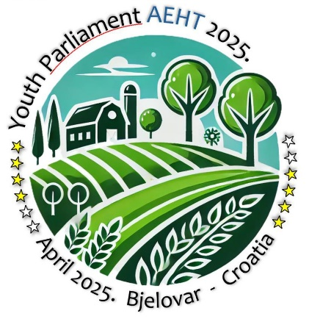

If you have questions, don't hesitate to contact us at yp2025tups@gmail.com.
We look forward to seeing you in Bjelovar!

Dalibor Vukalović, prof., director TUPŠ Bjelovar

THIS EVENT IS FUNDED BY:


